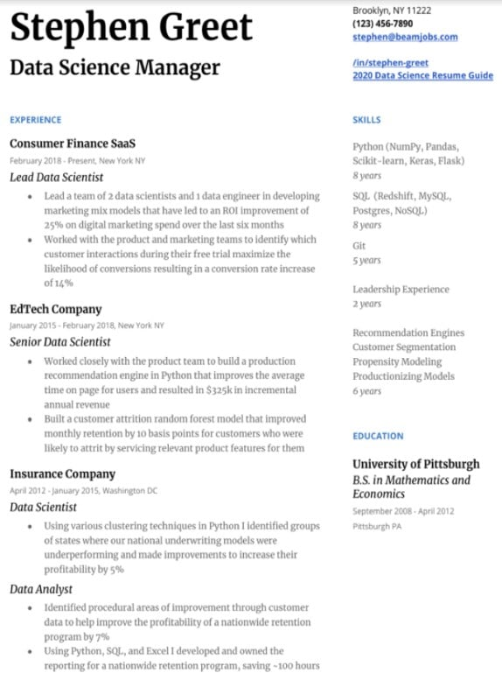
Stephen Greet
Data Science Manager
Brooklyn, NY 11222 (123) 456-7890 stephen@beamjobs.com
/in/stephen-greet
2020 Data Science Resume Guide
EXPERIENCE
Consumer Finance SaaS
February 2018-Present, New York NY
Lead Data Scientist
• Lead a team of 2 data scientists and 1 data engineer in developing marketing mix models that have led to an ROI improvement of 25% on digital marketing spend over the last six months
• Worked with the product and marketing teams to identify which customer interactions during their free trial maximize the likelihood of conversions resulting in a conversion rate increase of 14%
EdTech Company
January 2015-February 2018, New York NY Senior Data Scientist
• Worked closely with the product team to build a production recommendation engine in Python that improves the average time on page for users and resulted in $325k in incremental annual revenue
• Built a customer attrition random forest model that improved monthly retention by 10 basis points for customers who were likely to attrit by servicing relevant product features for them
Insurance Company
April 2012 January 2015, Washington DC
Data Scientist
⚫ Using various clustering techniques in Python I identified groups of states where our national underwriting models were underperforming and made improvements to increase their profitability by 5%
Data Analyst
• Identified procedural areas of improvement through customer data to help improve the profitability of a nationwide retention program by 7%
⚫ Using Python, SQL, and Excel I developed and owned the
reporting for a nationwide retention program, saving -100 hours
SKILLS
Python (NumPy, Pandas, Scikit-learn, Keras, Flask)
8 years
SQL (Redshift, MySQL, Postgres, NoSQL)
8 years
Git
5 years
Leadership Experience 2 years
Recommendation Engines Customer Segmentation Propensity Modeling Productionizing Models 6 years
EDUCATION
University of Pittsburgh B.S. in Mathematics and Economics
September 2008-April 2012 Pittsburgh PA

